Skybarrel Data Modelling Project
Group 1
Members: Serere, Nihi, Kaffy, Femi, Roju and Remi
Netflix Data Model
Reason for choice of domain:
The domain selected by the members of Group One is a streaming platform. During our brainstorming session for an appropriate domain, we identified a mutual interest among all members in watching movies and TV shows. As a result, we decided to develop a data model for a streaming application. Due to its prominence and popularity, Netflix was chosen as the ideal application to model.
A summary of the data that the model should contain:
Netflix provides visual media content such as movies and TV shows.
- Netflix has users who need to subscribe to a plan to access its services.
- Netflix offers different plans, such as basic and premium.
- Movies and TV shows are directed by directors.
- Users have a watch history.
- Users can have multiple profiles.
- Users can review the content they watch.
- Netflix offers media of various genres.
- A movie can belong to more than one genre.
- A user can have up to 4 profiles.

ER diagram
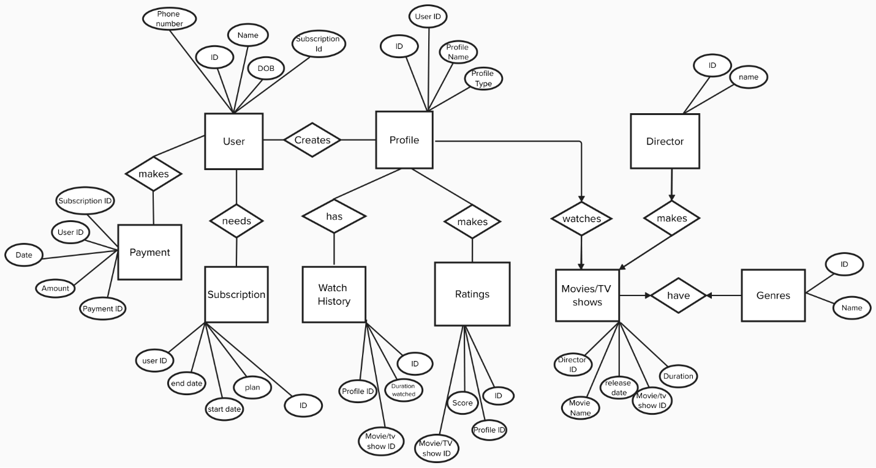
Entities
- User
- Profile
- Movies/TV shows
- Ratings
- Director
- Genre
- Watch History
- Subscription
- Payment

Conceptual Model
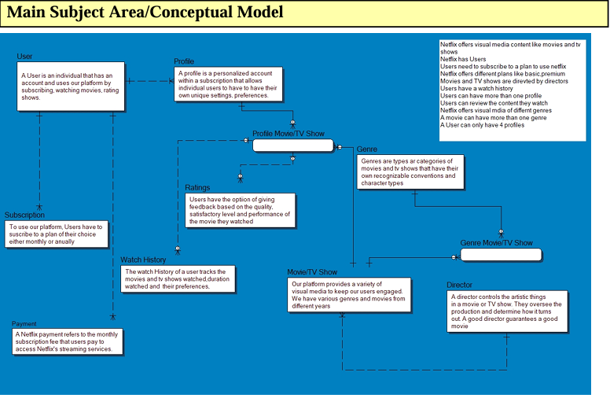
Logical Model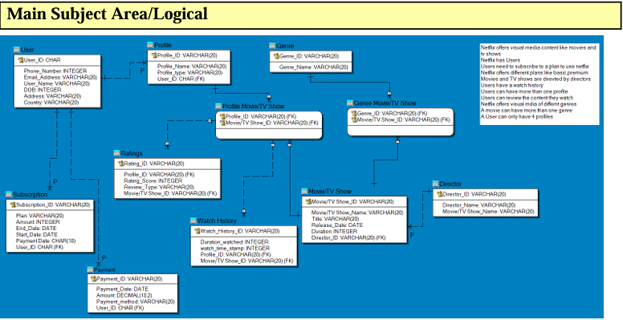

Physical Model
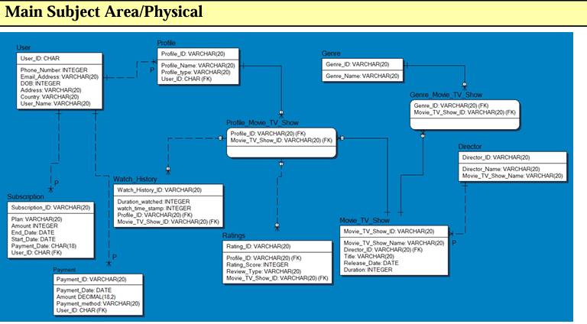

Relationships

- User to Profile: A Netflix User can have up to 4 profiles of different types. All profiles belong to one user making this a ONE-TO-MANY relationship

- User to Subscription: Netflix Users need to subscribe to a plan of their choice to use their services. The users over time have multiple subscriptions (renew their subscriptions and upgrading plans). But each subscription is associated with one user making this a ONE-TO-MANY relationship

- Movie/TV shows to Director: Directors can produce multiple movies/tv shows, but each movie has one director making this a ONE-TO-MANY relationship.

- Genre to Movie: A movie can have multiple genres, and a genre can have multiple movies/ tv shows associated to it making this a MANY-TO-MANY relationship

- Profile to Movie/TV shows: A profile can watch many movies/tv shows and a movie can be watched by many profiles making this a MANY-TO-MANY relationship.

- Profile to Ratings: A profile can have multiple ratings for different movies, but each rating must be associated with a profile making this a ONE-TO-MANY relationship

- Profile to Watch History: A Profile can have multiple Watch History entries but each watch history entry can only be associated with the profile it belongs to making it a ONE-TO-MANY relationship.

Key Choices and Description
User Table:
- User ID (Primary Key): A unique identifier for each user.

Profile Table
- Profile ID (Primary Key): A unique identifier for each profile.
- User ID (Foreign Key): A reference to the User ID in the User table.

Movie Table:
- Movie ID (Primary Key): A unique identifier for each movie.
- Genre ID (Foreign Key): A reference to the Genre ID in the Genre table.
- Director ID (Foreign Key): A reference to the Director ID in the Director table.

Genre Table:
- Genre ID (Primary Key): A unique identifier for each genre.

Director Table:
- Director ID (Primary Key): A unique identifier for each director.

Rating Table:
- Rating ID (Primary Key): A unique identifier for each rating.
- Profile ID (Foreign Key): A reference to the Profile ID in the Profile table.
- Movie ID (Foreign Key): A reference to the Movie ID in the Movie table.

Subscription Table:
- Subscription ID (Primary Key): A unique identifier for each subscription.
- User ID (Foreign Key): A reference to the User ID in the User table.

Payment Table:
- Payment ID (Primary Key): A unique identifier for each payment.
- User ID (Foreign Key): A reference to the User ID in the User table.

Watch History Table:
- Watch History ID (Primary Key): A unique identifier for each watch history record.
- Profile ID (Foreign Key): A reference to the Profile ID in the Profile table.
- Movie ID (Foreign Key): A reference to the Movie ID in the Movie table.

Design Decisions and Challenges
- Ensuring Correct Relationships
While creating this data model, one of the challenges we had was ensuring correct relationship between tables (one to many and many to many) without creating unnecessary junction tables.

- Avoiding Data Redundancy: We had issues when we were creating tables because we often repeated User ID in multiple tables where it was not needed causing data redundancy. We solved this by defining primary and foreign keys.

- Ensuring Referential Integrity: While we were setting up primary and foreign keys, we had to make sure that we maintained referential integrity between tables for instance a movie was created by a director therefore it has to reference the director table.

Reasons for Choice of Entities:
1. User:
- Reason: Represents individual users who subscribe to Netflix. Essential for managing user accounts and personal information.
2. Profile:
- Reason: Users can have multiple profiles (e.g., for family members) under a single account. Profiles allow personalized experiences and recommendations.
3. Movie/Tv shows:
- Reason: Represents movies/TV shows available on Netflix. Central to the content that users watch and rate.
4. Genre:
- Reason: Movies/TV shows are categorized by genres (e.g., Action, Comedy) to help users find content they like. Simplifies content classification and recommendations.
5. Director:
- Reason: Identifies the directors of movies. Useful for users who follow specific directors and for categorizing movies by creators.
6. Rating:
- Reason: Captures user ratings for movies. It is important for gathering user feedback and improving recommendations.
7. Subscription:
- Reason: Represents the subscription plans users choose. It is necessary for managing billing and subscription services.
8. Payment:
- Reason: Tracks payments made by users. Essential for financial transactions and billing records.
9. Watch History:
- Reason: Records the viewing history of profiles. Useful for personalized recommendations, user analytics, and tracking user activity.

